**Smart Farmer-IOT Enabled Smart Farming Application**

|  |  |
| --- | --- |
| **Date** | 14 November 2022 |
| **Team ID** | PNT2022TMID31434 |
| **Project Name** | Smart Farmer-IOT Enabled Smart Farming Application |

**Project Development Phase**

**Sprint Delivery -4**

**Web UI:**

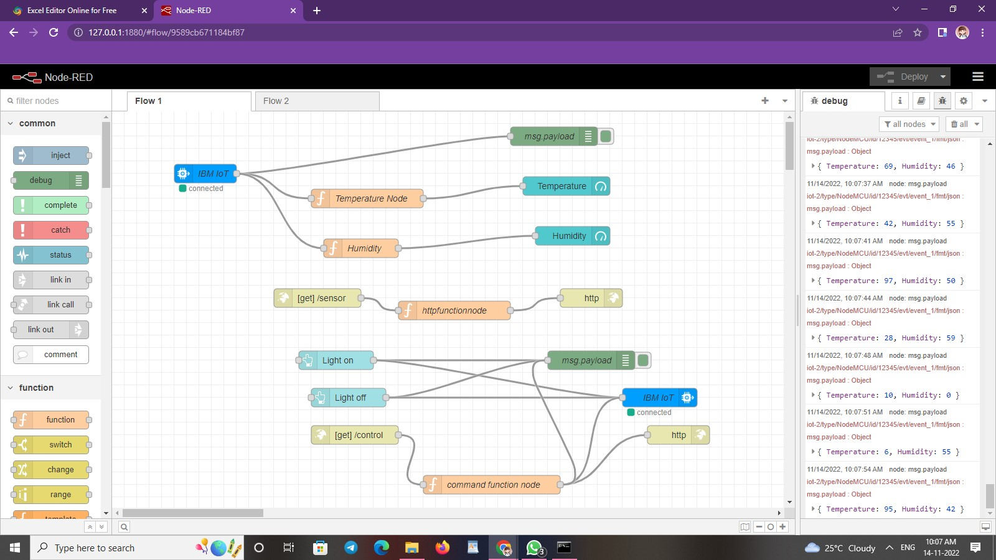

**To make the user interact with the software:**

**NODE RED URL :** http://127.0.0.1:1880/

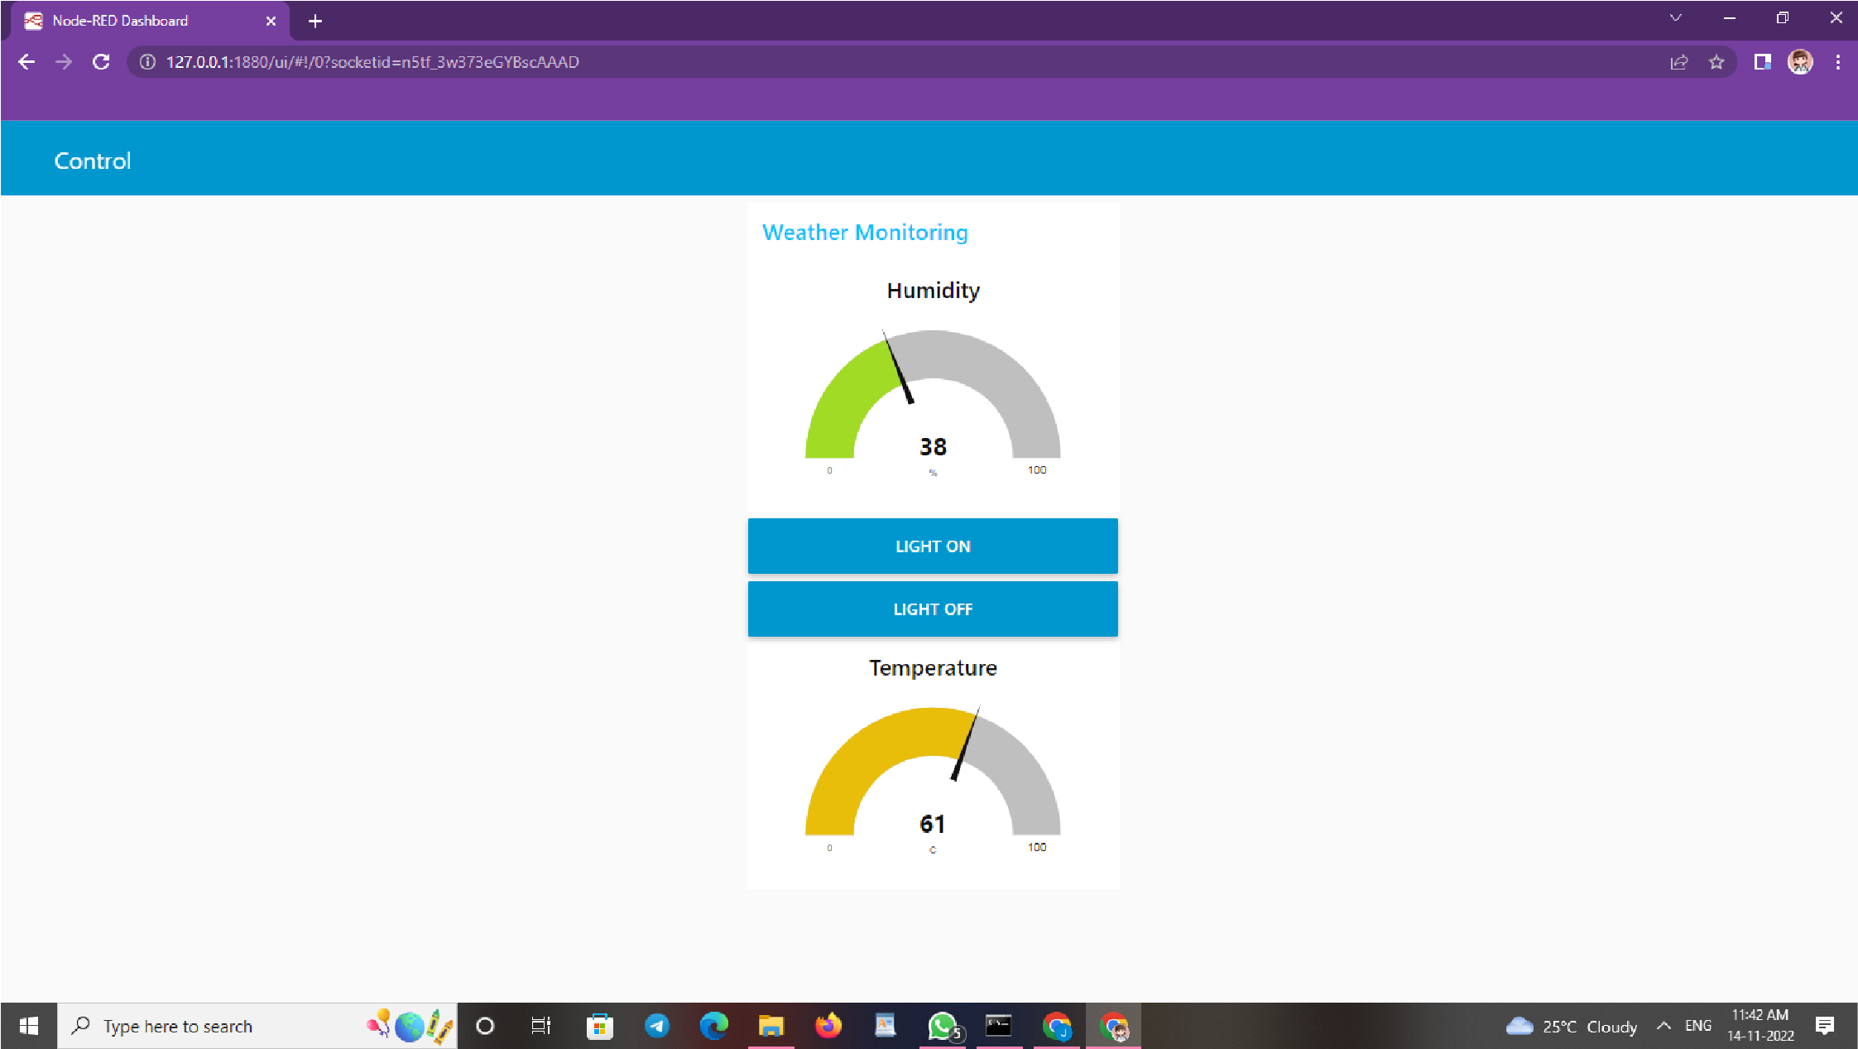**URl :** http://127.0.0.1:1880/ui/#!/0?socketid=DxhTmt9mXlcfkTOsAAAH

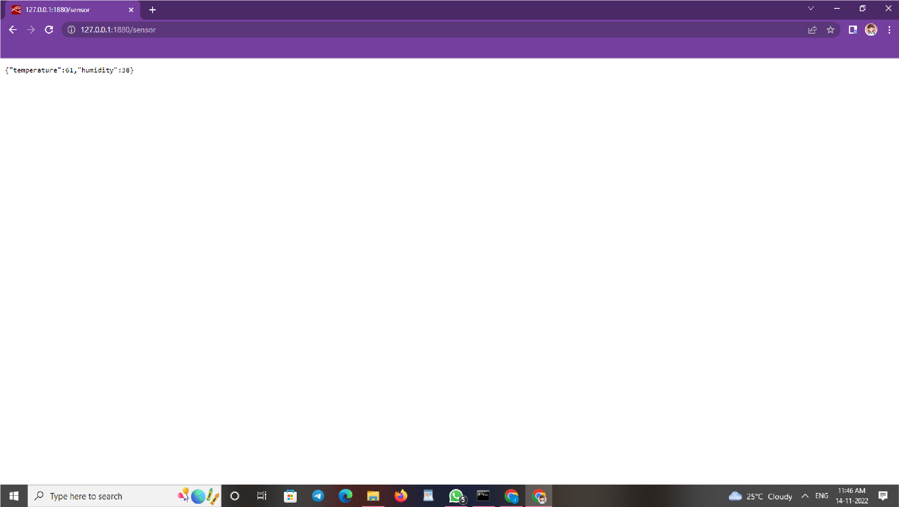**URL:** http://127.0.0.1:1880/sensor